Headings and Accessibility
Appropriate use of headings in your digital media development is not only beneficial for automating tasks like generating a table of contents in Word, but they are also very useful for those using assistive technologies to navigate your documents.
Headings indicate the organization of a document’s contents and the relationship of sections. Here’s an outline for an example document I would write:

Thoughts On Dogs (H1)

I Love My Dogs (H2)

Life with Finn (H3)

Life with Gus (H3)

I Love All Other Dogs (H2)

Goldens are Sweet (H3)

Corgis are Fun (H3)

The order and instruction are important. Everything under the top-level heading, H1, relates to it. If you don’t need to breakdown the structure any more than that, at least you’ve provided a solid indication as to the intent of the content that appears beneath. Most often, though, you will need to further breakdown and organize the content of your document to include related subsections, for which you’ll use increasingly higher numbered headers, starting with H2 and going through H6, with H6 being the least important section(s). A screen reader can use those headings to convey the purpose of the content in each section and navigate directly to a desired section of the document.
Do not skip levels of headers within a section. Do not, for instance, follow up an H3 with an H5, skipping H4. It is confusing to readers and makes the document less scannable.
If you generate headings correctly, you can also use them to create bookmarks in PDFs to make them more accessible as well!

Adding Headers
Headings are not simply lines of text that have special formatting, though headings are often formatted to a certain style. To qualify as a heading in a document, you must mark up the text to indicate that it is a heading. For example, in a Word document, to indicate that a piece of text is a heading:
- Highlight the text in question.
- In the Home menu of the ribbon, choose the correct heading from the Styles section. 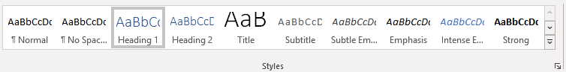
Location of the Headings option in the Styles ribbon
You have now created the necessary heading markup in your document. You can change the style to suit your needs without affecting the technical heading. You cannot, however, style normal text just like a heading and have it act as one.
This is a Heading

This is a Heading
You can’t really tell by just looking at the two sentences above which one is an actual heading; both are styled the same. However, if you were to highlight the first line of text, you would see that in the Styles section, it is using the Normal style. Highlighting the second line of text reveals that it has an actual Heading 1 style applied.
If you don’t like the look of the heading, you can always change styles.

I’m A Bland Heading

I’m A Fabulous Heading!

These are both still text with the Heading 1 style applied, but the second one has additional formatting. Don’t let default styling of headings keep you away from using them!

